1. **Introduction**

This user guide provides information on how to open a MemoQ file in SDL Trados Studio and how to open an SDL Trados Studio file in MemoQ. This document includes written instructions and visual information to help the user in completing the task. There is also general information on CAT tools and translation management systems as well as glossaries and translation memories in MemoQ and SDL Trados Studio.

* 1. **CAT Tools**
  2. **Translation Management Systems**

1. **MemoQ**

**2.1. About MemoQ**

**2.2. Installation**

**2.3. Setting up the account**

**2.4. Features(?)**

**2.5. More(?)**

**3. SDL Trados Studio**

**3.1. About SDL Trados**

**3.2. Installation**

**3.3. Setting up the account**

**3.4. Features(?)**

**3.5. More(?)**

1. **User Guide**

**4.1. How to open a Trados file in MemoQ.**

1. Open MemoQ.
2. Drag and drop the Trados file (.sdlxliff) that you want to use into the designated space.

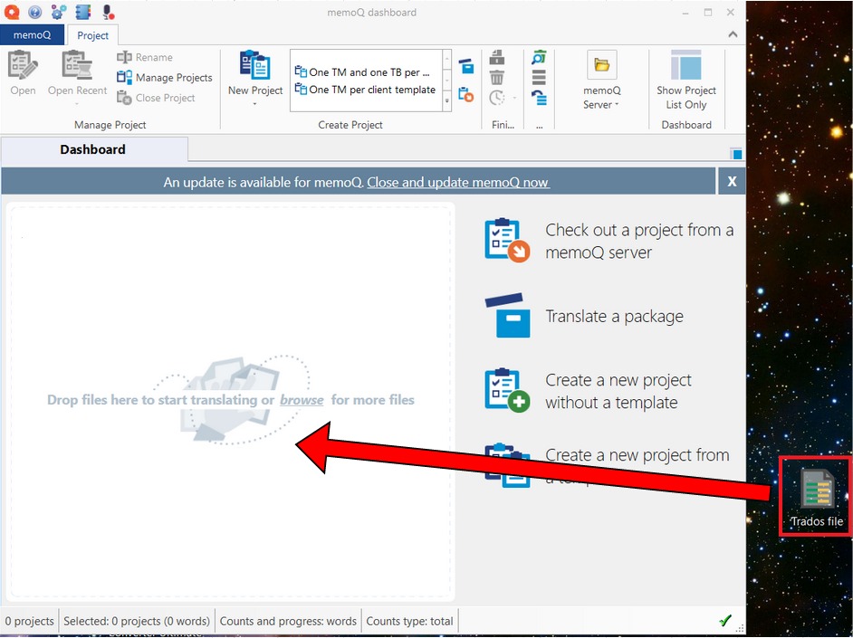

1. Click *Start translating*.

1. Create a new project from template. Enter the information, and click *Finish*.

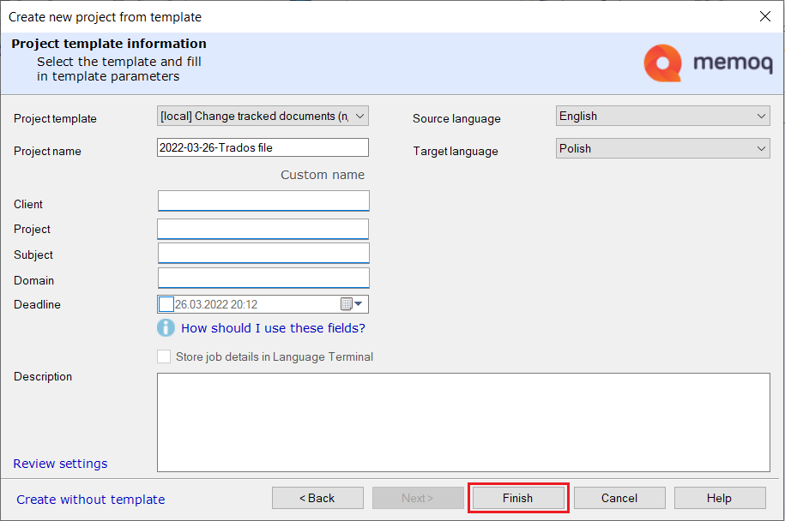

1. Wait for the operation to complete, and click *Close*.

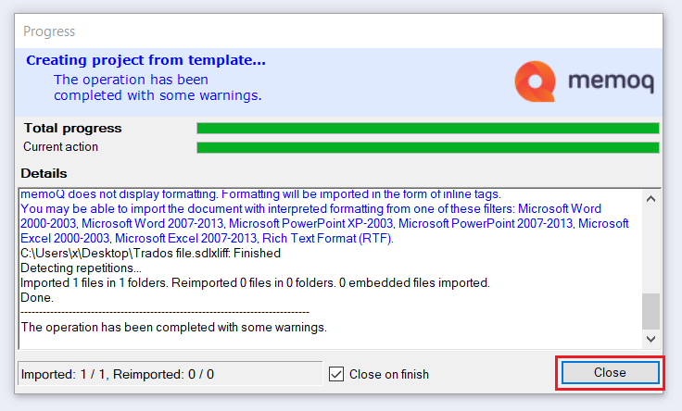

1. You have successfully added the file. In the *Translations* panel, double click it to open it.
   1. **How to open a MemoQ file in Trados.**
2. **Translation memories (and glossaries?)**

**5.1. MemoQ**

**5.2. SDL Trados Studio**

1. **Glossaries(?)**

Glossaries (also called term bases) are databases that contain words or phrases connected with a particular vocabulary item. They are often bilingual but can include more languages.

* 1. **MemoQ**

1. To create a new term base, go to the *Term bases* section of your project.

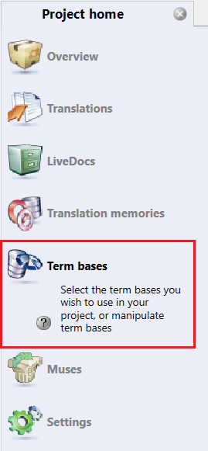

1. Click *Create/Use New*.

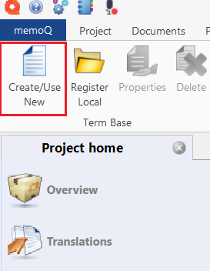

1. (1) Enter the base properties and meta-information of the term base. (2) Choose the languages of the terms. (3) Click *OK*.

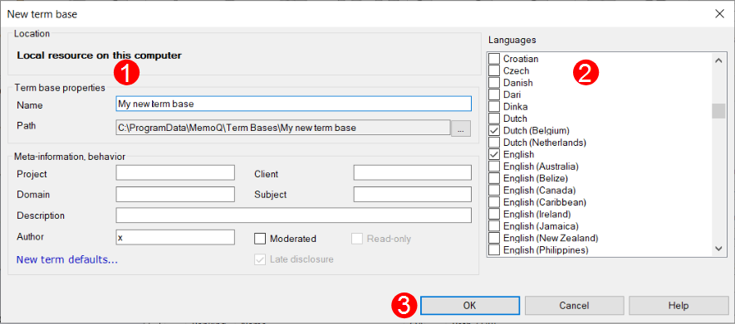

* 1. **SDL Trados Studio**

1. **Glossary**
2. **Useful links**

<https://webassets.rws.com/static/tp/2021-interactive/index.html>

<https://docs.memoq.com/current/en/Places/import-sdl-studio-package.html>